Random Forrest **n-estimators = 128**

Random Forrest **n-estimators = 256**

Random Forrest **n-estimators = 1000**

Random Forrest **n-estimators = 5000**

**Random Forrest Boosted n-estimators = 20 learning Rate = 1**

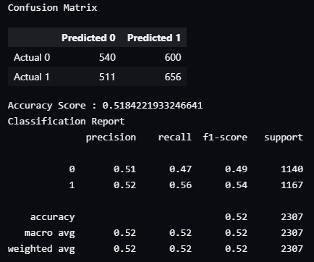

**Random Forrest Boosted n-estimators = 2000 Learning Rate = 1**

**Random Forrest Boosted n-estimators = 2000 Learning Rate = 0.75**

11/27/22

Simple Logistic Regression 10000 Iterations (popular_features_fighters)

11/27/22

Simple Logistic Regression 10000 Iterations (popular_features_camps)

11/27/22

SVM (popular_features_fighters)

11/27/22

SVM (popular_features_camps)

11/29/22

Simple Logistic Regression 10000 Iterations (ufc_fights_locations)

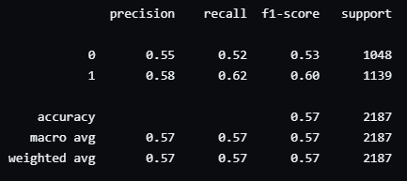

11/29/22

SVM (ufc_fights_locations)

11/30/22

Random Forrest **n-estimators = 5000 (fight_id_top39_test)**

11/30/22

Random Forrest **n-estimators = 5000 (fight_id_top39_test) with out camps**

11/30/22

Random Forrest **n-estimators = 5000 (fight_id_top39_test) with out camps and locations**

11/30/22

Random Forrest **n-estimators = 5000 (fight_id_top39_test) top 10 features only**

